**Harnessing data mining tools to evaluate the impact of the meat industry on climate.**

**Anmol Negi1, Ishita Singh2, Paridhi Gupta2, Ashwina Prasad1, Aayush Kukreja1, Preeti Nandal2, Vineeta Sharma2, Jayant Maini2\***

1Department of Computer Sciences and Engineering, School of Engineering and Technology, Manav Rachna International Institute of Research and Studies, Faridabad, Haryana, India

2Department of Biotechnology, School of Engineering and Technology, Manav Rachna International Institute of Research and Studies, Faridabad, Haryana, India

*Corresponding Author

Correspondence at jayant.set@mriu.edu.in

**Abstract**

The meat industry has a significant impact on climate change. Cattle contribute to 13-17% of the greenhouse gas emissions annually along with the collateral damage associated with deforestation of grasslands and increasing antimicrobial resistance. To call attention to this issue, the authors employed advanced data science techniques to extract insights from IPCC reports. Leveraging PyAMI HTML, PyGetPapers and using docanalysis, the team meticulously analysed specific sections related to food security, focusing on occurrence of the keyword "meat” and extracting valuable insights from IPCC reports, translating them into graphs, tables and CSV files. The analysis led to the following observations a) a drastic increase in annual meat consumption from the year 1990 to 2020 which b) correlated with the increase in annual methane emissions 1960 to 2010, with cattle being a major contributor. With this the authors bring a sharp focus on the problem of meat industries and its major contribution to the threat we face in the form of climate change. Furthermore, this technical contribution seeks to instill informed decision making and collaborative action towards a sustainable future, tackling a small portion of the massive issue of climate change.

KeyWords: meat industry, data mining, IPCC, PyAMI, PyGetPapers, Docanalysis

**Introduction**

Awareness about climate change is crucial for developing a global commitment to environmental sustainability. The meat industry has a significant impact on climate change *(Impacts of climate change on the livestock food supply chain; a review of the evidence* [*C.M. Godde*](https://pubmed.ncbi.nlm.nih.gov/?term=Godde%20C%5BAuthor%5D)*,* [*D. Mason-D’Croz*](https://pubmed.ncbi.nlm.nih.gov/?term=Mason-D%E2%80%99Croz%20D%5BAuthor%5D)*,* [*D.E. Mayberry*](https://pubmed.ncbi.nlm.nih.gov/?term=Mayberry%20D%5BAuthor%5D)*,* [*P.K. Thornton*](https://pubmed.ncbi.nlm.nih.gov/?term=Thornton%20P%5BAuthor%5D)*, and* [*M. Herrero*](https://pubmed.ncbi.nlm.nih.gov/?term=Herrero%20M%5BAuthor%5D)), contributing to greenhouse gas emissions (*Cassandra Brooks, Stanford's Woods Institute, 2011*), deforestation (*Jesse Peterson, earth.org, 2024*), and resource depletion (*Humane Foundation, December 20, 2023*). Livestock production is responsible for a substantial portion of methane emissions, which is released from the digestive processes of ruminating animals (*Advances in Methane Emission Estimation in Livestock: A Review of Data Collection Methods, Model Development and the Role of AI Technologies* [*Jalil Ghassemi Nejad*](https://pubmed.ncbi.nlm.nih.gov/?term=Ghassemi%20Nejad%20J%5BAuthor%5D)*,* [*Mun-Su Ju*](https://pubmed.ncbi.nlm.nih.gov/?term=Ju%20MS%5BAuthor%5D)*,* [*Jang-Hoon Jo*](https://pubmed.ncbi.nlm.nih.gov/?term=Jo%20JH%5BAuthor%5D)*,* [*Kyung-Hwan Oh*](https://pubmed.ncbi.nlm.nih.gov/?term=Oh%20KH%5BAuthor%5D)*,* [*Yoon-Seok Lee*](https://pubmed.ncbi.nlm.nih.gov/?term=Lee%20YS%5BAuthor%5D)*,* [*Sung-Dae Lee*](https://pubmed.ncbi.nlm.nih.gov/?term=Lee%20SD%5BAuthor%5D)*,* [*Eun-Joong Kim*](https://pubmed.ncbi.nlm.nih.gov/?term=Kim%20EJ%5BAuthor%5D)*,* [*Sanggun Roh*](https://pubmed.ncbi.nlm.nih.gov/?term=Roh%20S%5BAuthor%5D)*, and* [*Hong-Gu Lee*](https://pubmed.ncbi.nlm.nih.gov/?term=Lee%20HG%5BAuthor%5D) *).* Large-scale deforestation occurs to create pasture land and grow feed crops, which not only releases carbon dioxide stored in trees but also reduces the planet's capacity to absorb atmospheric CO2 *(Kateryna Sergieieva, 2023, Deforestation & Greenhouse Gases: Why Do Forests Matter)* . In addition to these, the extensive use of antibiotics in animal farming contributes to the growing problem of antimicrobial resistance, posing a significant threat to global public health *(Antibiotic Use in Agriculture and Its Consequential Resistance in Environmental Sources: Potential Public Health Implications* [*Christy Manyi-Loh*](https://pubmed.ncbi.nlm.nih.gov/?term=Manyi-Loh%20C%5BAuthor%5D)*,* [*Sampson Mamphweli*](https://pubmed.ncbi.nlm.nih.gov/?term=Mamphweli%20S%5BAuthor%5D)*,* [*Edson Meyer*](https://pubmed.ncbi.nlm.nih.gov/?term=Meyer%20E%5BAuthor%5D)*, and* [*Anthony Okoh*](https://pubmed.ncbi.nlm.nih.gov/?term=Okoh%20A%5BAuthor%5D) ). These factors collectively make the meat industry a major driver of climate change and environmental degradation, highlighting the need for sustainable practices and dietary shifts to mitigate its impact.The impacts of climate change such as increasing temperatures and changing precipitation patterns are already affecting the security of food systems and negative impacts are expected to increase based on future projected climate change, resulting in further declines of crop yields and increasingly food prices. ([IPCC](https://www.ipcc.ch/srccl/chapter/chapter-5/)).

The goal of this technical contribution is to instill informed decision-making and foster collaborative action towards a sustainable future, addressing a small aspect of the immense issue of climate change. The main source used in this project was the SRCCL (Special Report on Climate Change and Land, Chapter 5 - Food Security from the AR6 (Assessment Report 6) of the IPCC. This report highlights how climate change impacts food and nutrition security, including factors like food availability, access, affordability, and stability. It explores how these aspects may change in the future due to climate change, distinguishing between natural and human-caused influences. It further investigates the effects of climate change on food production, prices, and livelihoods, as well as the reciprocal relationship between food security and climate change. Additionally, it proposes strategies for adapting to these changes and reducing greenhouse gas emissions from food production. The study also highlights the importance of sustainable land management in enhancing food security and mitigating climate change. Through case studies and examples, it provides valuable insights into these interconnected issues. The information required to undertake current study was filtered out and modified using various tools and libraries like PyamiHTML, docanalysis, and PyGetPapers. Through this modification, data embedded in the report was extracted in the form of .csv files which was then used to generate useful visual representations. Apart from this, useful information from a range of sources, including academic papers (NIH, PubMed) and datasets (kaggle.com) on topics like livestock farming, consumption trends, and environmental consequences, were collated. Quality check of the gathered data was done to validate its reliability and appropriateness.

**Methodology**

The data was extracted from the Intergovernmental Panel on Climate Change (IPCC) report and analyzed to identify the role of the meat industry in environmental degradation. We focused on the fifth chapter of the report on Food Security of the SRCCL (Special Report on Climate Change and Land) and various other data sources, including scholarly articles, government reports, and datasets related to livestock production, consumption patterns, and environmental impacts. Furthermore, the team verified the collected data to ensure its quality and suitability for analysis.

We then worked on establishing a methodological framework for the analysis, considering the objectives of the research and the nature of the data. This step involved the selection of appropriate data science techniques and text mining tools such as PyAMI HTML, PyGetPapers and docanalysis. This included converting the report into HTML format, parsing the text, and identifying key passages related to food security and the meat industry. Statistical analysis was conducted through matplotlib.pyplot to examine trends and patterns in livestock production and consumption over time.

We then analyzed the extracted data to assess the impact of the meat industry on climate change and food security. This involved exploring correlations, trends, and associations between variables such as livestock production and greenhouse gas emissions. Visualizations, such as graphs, charts, and maps, were created to illustrate the findings of the analysis. This facilitated the communication of complex relationships and trends in a clear and accessible manner. After required survey and analysis, the visual representation of relevant information was carried out.

**Result and discussions**

The period between 1990-2030 (Figure 1), shows a marked increase in meat consumption.

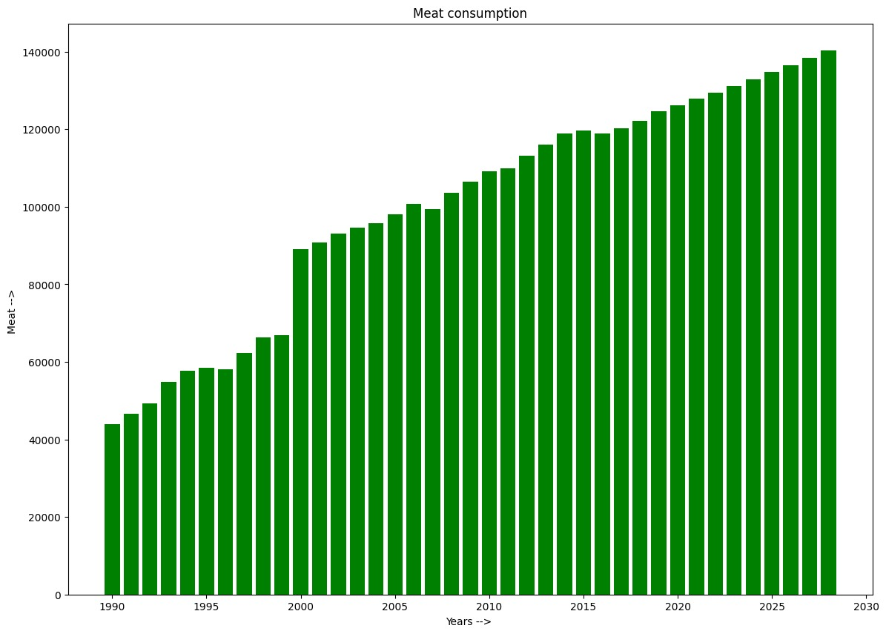

Figure-1 The above graph highlights a significant and sustained increase in meat consumption with a notable rapid growth phase in the early years, followed by a more gradual increase in later years.

The early 2000s shows a jump followed by a steady increase. This trend indicates a growing demand for meat (which is itself correlated to population explosion and its dependence on meat for nutrition), which could have implications for agricultural practices, food supply chains, and environmental impacts.This data is supported by study (Devi et al.,2014), where the per capita meat consumption for goat, beef, pork and chicken is 0.053 Kg, 0.037 Kg, 0.006Kg and 0.059Kg, respectively (Devi et al.,2014).According to the study, herd expansion (Bovine herd) showed a correlated increase with meat production (Beef production) between 2003 to 2013). According to an article in Gaurdian (Milman, 2021), beef-based food contributes to 4 billion metric tonnes of greenhouse gas emission. We were interested in comparing overall meat production and consumption with that of methane emission in India.

Hence we first compared the methane emission by livestock in the year 1967 to that of 2010. This comparison identified the major culprits of methane emission as cattle and buffalo followed by mule and goat.

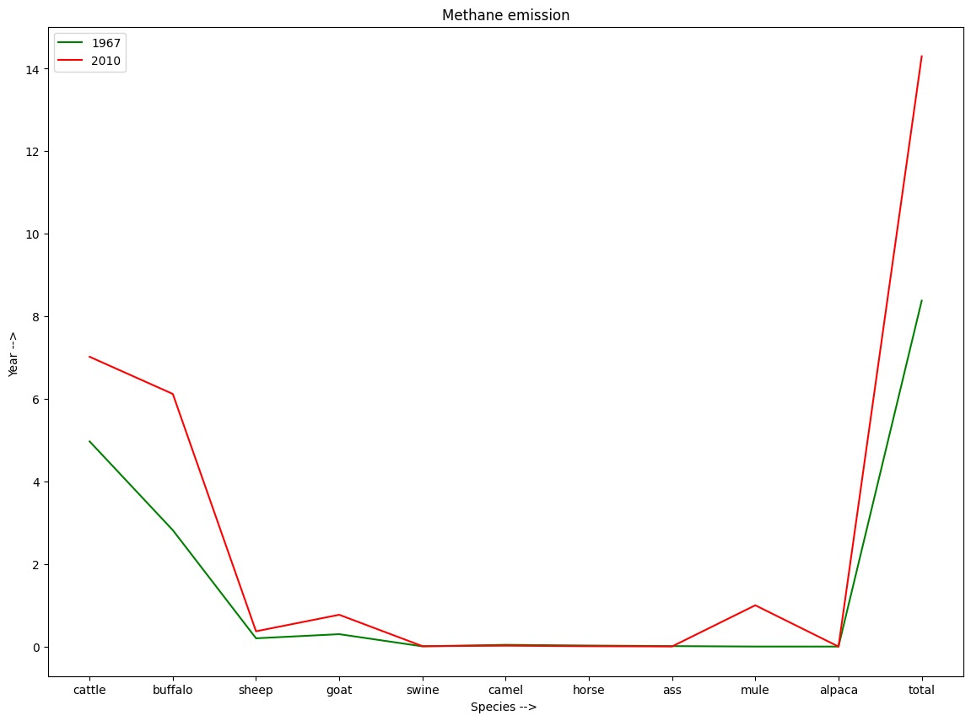

Figure-2 The graph highlights a significant rise in methane emissions in the year 1967 and 2010, with cattle and buffalo being the major contributors

This increase in emissions may be attributed to changes in increased livestock populations, agricultural practices, and possibly changes in livestock management over the years. These trends have important implications for environmental policies and efforts to mitigate greenhouse gas emissions.

Following this we also charted the course of animal slaughtering in India between 1960 and 2020 (Figure 3). This trend (Figure 3) signifies a rate at which species such as cattle, goats, pigs, lambs, and ducks are slaughtered. Y-axis signifies the rate (where 1 indicates slaughtering rate is low, 2 is moderate & 3 is high) with respect to X-axis which signifies that slaughtering over the period (in years).

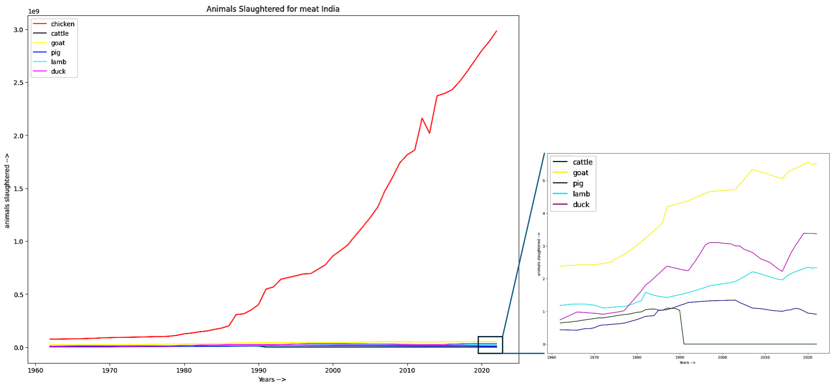

Figure-3 The graph clearly demonstrates a dramatic rise in chicken slaughtering compared to species such as cattle, goats, pigs, lambs, and ducks (expanded) for meat in India from 1960 to 2020. ([*Yearly number of animals slaughtered for meat, World(ourworldindata.org)*](https://ourworldindata.org/grapher/animals-slaughtered-for-meat))

Upon closer inspection, it becomes evident that chickens exhibit the most significant increase compared to other species. This finding is particularly intriguing from the perspective of India's poultry industry, which has experienced significant growth and transformation in between the years (1960 to 2020) (Chatterjee and Rajkumar, 2015; Ricky Thaper, 2024). Apart from Chicken, goat slaughter also shows an upward trend followed by duck and lamb slaughter. The heightened deviation observed in chickens underscores the unique challenges and opportunities inherent in poultry farming, ranging from genetic selection and breeding programs to housing systems and disease management practices.

Correlation between meat slaughter with methane emission shows a positive trend especially from 1960 to present. The Initial increase in methane emission from 1850 to early 1950s, although not very significant, can be attributed to the energy sector (coal, natural gas and biofuels), which comes second to the agriculture sector in methane emission (International Energy Agency, Methane tracker, 2021). But starting from the late 1950s there is a steady increase in methane emission that correlates with a drastic increase in meat slaughter.

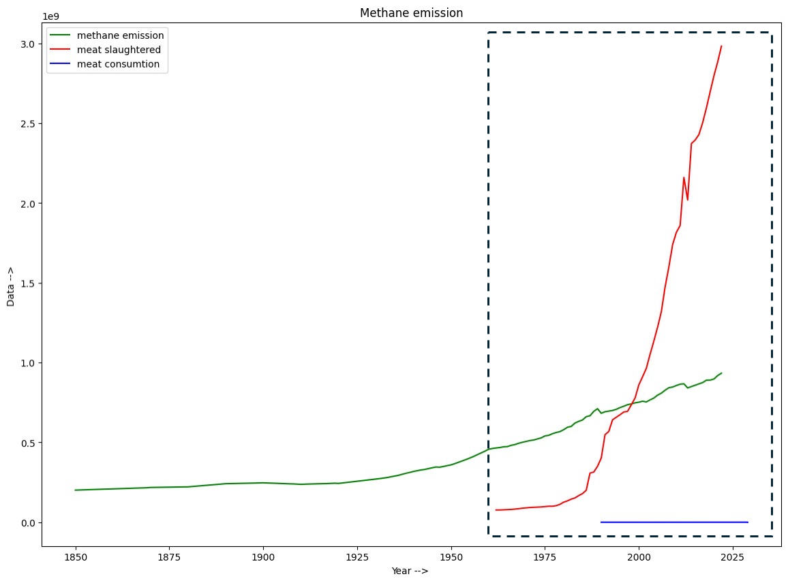

Furthermore, Indians in the 21st century are experiencing changes in lifestyle and food habits coupled with a population surge. The per capita annual consumption of meat has increased to 4.4 kg per person and is placing pressure on production lines. This, in turn, has resulted in greater demands for water and land resources for rearing livestock (*Yashika Kapoor, indiabioscience.org, 2019*). If this trend continues, it will lead to irreversible damage caused by greenhouse gas emission and pushing climate change to the point of no return.

**Conclusion**

This project highlights the significant role of the meat industry in contributing to climate change (methane emission) while highlighting the urgency of addressing this issue. By employing advanced data science techniques to extract insights from IPCC reports, the team was able to analyze specific sections related to food security and meat consumption, revealing alarming trends in annual meat consumption and methane emissions from cattle. This technical contribution not only sheds light on the environmental impacts of the meat industry but also seeks to inform decision-making and initiate collaborative action towards a sustainable future. By leveraging text mining and data visualization tools, this program enables stakeholders to extract valuable information from research sources embedded in IPCC chapters, facilitating evidence-based policy development and mitigation strategies. Overall, this abstract emphasizes the importance of addressing the meat industry's contribution to climate change and environmental degradation through informed decision-making and collective efforts towards sustainability.

**References**

1. *Devi SM, Balachandar V, Lee SI, Kim IH. An Outline of Meat Consumption in the Indian Population - A Pilot Review. Korean J Food Sci Anim Resour. 2014;34(4):507-15. doi: 10.5851/kosfa.2014.34.4.507. Epub 2014 Aug 31. PMID: 26761289; PMCID: PMC4662155.*
2. *R.N. Chatterjee and U. Rajkumar. An overview of Poultry production in India. Indian J. Anim. Hlth. (2015), 54(2) : 89-108.*
3. *Ricky Thaper. The expanding landscape of India’s poultry sector. 22nd January, 2024. The Poultry Site (*[*https://www.thepoultrysite.com/articles/the-expanding-landscape-of-indias-poultry-sector#:~:text=According%20to%20EMR%20market%20research,USD%20%2444.97%20billion%20by%202032.*](https://www.thepoultrysite.com/articles/the-expanding-landscape-of-indias-poultry-sector#:~:text=According%20to%20EMR%20market%20research,USD%20%2444.97%20billion%20by%202032.)*)*
4. *Methane and Climate Change. Methane Tracker 2021, International Energy Agency.(*[*https://www.iea.org/reports/methane-tracker-2021/methane-and-climate-change#*](https://www.iea.org/reports/methane-tracker-2021/methane-and-climate-change#)*)*
5. *IPCC SRCCL Chapter 5- Food Security Mbow, C., C. Rosenzweig, L.G. Barioni, T.G. Benton, M. Herrero, M. Krishnapillai, E. Liwenga, P. Pradhan, M.G. Rivera-Ferre, T. Sapkota, F.N. Tubiello, Y. Xu, 2019: Food Security. In: Climate Change and Land: an IPCC special report on climate change, desertification, land degradation, sustainable land management, food security, and greenhouse gas fluxes in terrestrial ecosystems [P.R. Shukla, J. Skea, E. Calvo Buendia, V. Masson-Delmotte, H.-O. Pörtner, D.C. Roberts, P. Zhai, R. Slade, S. Connors, R. van Diemen, M. Ferrat, E. Haughey, S. Luz, S. Neogi, M. Pathak, J. Petzold, J. Portugal Pereira, P. Vyas, E. Huntley, K. Kissick, M. Belkacemi, J. Malley, (eds.)].* <https://doi.org/10.1017/9781009157988.007>
6. *Impacts of climate change on the livestock food supply chain; a review of the evidence* [*C.M. Godde*](https://pubmed.ncbi.nlm.nih.gov/?term=Godde%20C%5BAuthor%5D)*,* [*D. Mason-D’Croz*](https://pubmed.ncbi.nlm.nih.gov/?term=Mason-D%E2%80%99Croz%20D%5BAuthor%5D)*,* [*D.E. Mayberry*](https://pubmed.ncbi.nlm.nih.gov/?term=Mayberry%20D%5BAuthor%5D)*,* [*P.K. Thornton*](https://pubmed.ncbi.nlm.nih.gov/?term=Thornton%20P%5BAuthor%5D)*, and* [*M. Herrero*](https://pubmed.ncbi.nlm.nih.gov/?term=Herrero%20M%5BAuthor%5D) [Glob Food Sec.](https://www.ncbi.nlm.nih.gov/pmc/articles/PMC7938222/#) 2021 Mar; 28: 100488. Published online 2021 Mar. doi: [10.1016/j.gfs.2020.100488](https://doi.org/10.1016%2Fj.gfs.2020.100488)
7. *Cassandra Brooks, Stanford's Woods Institute, 2011* URL-

<https://woods.stanford.edu/news/meats-environmental-impact#:~:text=Livestock%20production%20accounts%20for%2018,private%20agencies%20based%20at%20FAO>

1. *Jesse Peterson, earth.org, 2024 URL-*

[*https://earth.org/how-animal-agriculture-is-accelerating-global-deforestation/#:~:text=The%20primary%20catalyst%20behind%20global,the%20size%20of%20the%20Netherlands*](https://earth.org/how-animal-agriculture-is-accelerating-global-deforestation/#:~:text=The%20primary%20catalyst%20behind%20global,the%20size%20of%20the%20Netherlands)*.*

1. *"Confronting the Truth: The Catastrophic Effects of the Meat Industry on Our World" , Humane Foundation,December20,2023 URL-*[*https://www.linkedin.com/pulse/confronting-truth-catastrophic-effects-meat-industry-qaure/*](https://www.linkedin.com/pulse/confronting-truth-catastrophic-effects-meat-industry-qaure/)
2. *Advances in Methane Emission Estimation in Livestock: A Review of Data Collection Methods, Model Development and the Role of AI Technologies* [*Jalil Ghassemi Nejad*](https://pubmed.ncbi.nlm.nih.gov/?term=Ghassemi%20Nejad%20J%5BAuthor%5D)*,* [*Mun-Su Ju*](https://pubmed.ncbi.nlm.nih.gov/?term=Ju%20MS%5BAuthor%5D)*,* [*Jang-Hoon Jo*](https://pubmed.ncbi.nlm.nih.gov/?term=Jo%20JH%5BAuthor%5D)*,* [*Kyung-Hwan Oh*](https://pubmed.ncbi.nlm.nih.gov/?term=Oh%20KH%5BAuthor%5D)*,* [*Yoon-Seok Lee*](https://pubmed.ncbi.nlm.nih.gov/?term=Lee%20YS%5BAuthor%5D)*,* [*Sung-Dae Lee*](https://pubmed.ncbi.nlm.nih.gov/?term=Lee%20SD%5BAuthor%5D)*,* [*Eun-Joong Kim*](https://pubmed.ncbi.nlm.nih.gov/?term=Kim%20EJ%5BAuthor%5D)*,* [*Sanggun Roh*](https://pubmed.ncbi.nlm.nih.gov/?term=Roh%20S%5BAuthor%5D)*, and* [*Hong-Gu Lee*](https://pubmed.ncbi.nlm.nih.gov/?term=Lee%20HG%5BAuthor%5D) *). doi:* [*10.3390/ani14030435*](https://doi.org/10.3390%2Fani14030435)
3. *Kateryna Sergieieva, 2023, Deforestation & Greenhouse Gases: Why Do Forests Matter*

*URL-* [*https://eos.com/blog/deforestation-and-greenhouse-gases/*](https://eos.com/blog/deforestation-and-greenhouse-gases/)

1. *Antibiotic Use in Agriculture and Its Consequential Resistance in Environmental Sources: Potential Public Health Implications* [*Christy Manyi-Loh*](https://pubmed.ncbi.nlm.nih.gov/?term=Manyi-Loh%20C%5BAuthor%5D)*,* [*Sampson Mamphweli*](https://pubmed.ncbi.nlm.nih.gov/?term=Mamphweli%20S%5BAuthor%5D)*,* [*Edson Meyer*](https://pubmed.ncbi.nlm.nih.gov/?term=Meyer%20E%5BAuthor%5D)*, and* [*Anthony Okoh*](https://pubmed.ncbi.nlm.nih.gov/?term=Okoh%20A%5BAuthor%5D) doi: [10.3390/molecules23040795](https://doi.org/10.3390%2Fmolecules23040795)
2. *Yashika Kapoor, indiabioscience.org 2019 URL-* [***https://indiabioscience.org/columns/indian-scenario/meating-the-needs-of-the-future***](https://indiabioscience.org/columns/indian-scenario/meating-the-needs-of-the-future)
3. *Yearly number of animals slaughtered for meat, World (ourworldindata.org)*

*URL-* [*Yearly number of animals slaughtered for meat, World, 1961 to 2022 (ourworldindata.org)*](https://ourworldindata.org/grapher/animals-slaughtered-for-meat)